# PROJECT REPORT ON

**Pankhudi Vidyapeeth**

Submitted for the completion of the course

#### “O level”

**Submitted by: Under the guidance of:**

Simran Kumari Sumit Singh Patel

**Submitted to:**



**SOFTECH COMPUTER EDUCATION**

99, Moti Nagar, Unnao

**DECLARATION**

**Dated: 25th - January-2022**

I hereby certify that the major project entitled “**Pankhudi Vidyapeeth**” submitted by **Simran Kumari** (Reg. No:**_________** ) in completion of “**O level**” submitted in the National Institute of Electronics & Information Technology New Delhi, is an authentic record of our own work carried out under the supervision of **Mr. Sumit Singh Patel**

**Simran Kumari**

**Reg. No.**

This is to certify that the above statement made by the candidate is correct to the best of my knowledge

**Mr. Sumit Singh Patel Noor Islam Khan**

**Project Coordinator Center Head**

**Acknowledgement**

It gives me great pleasure & satisfaction to present major project report entitled **“Pankhudi Vidyapeeth”** The completion of any task is not only the reward to the person actively involved in accomplishing it, but also the person involved in inspiring & guiding. I am highly indebted to my supervisor **Mr. Sumit Singh Patel** for his invaluable support and guidance throughout the work.

My Thanks and appreciations also go to my colleague “**Alka Singh**” in developing the project and people who have willingly helped me out with their abilities.

I would like to express my gratitude towards my Institute (Softech Computer Education) and my parents for their kind co-operation and encouragement which help me in completion of this project.

**Simran Kumari**

__________

|  |  |  |
| --- | --- | --- |
| **S.No.** | **Description** | **Page** |
| **1** | Declaration | 2 |
| **2** | Acknowledgement | 3 |
| **3** | Technology Used | 4 |
| **4** | Project Objective | 5 |
| **5** | SnapShot of All Pages | 6-18 |
| **6** | Coding of all pages | 18-48 |
| **7** | Conclusion |  |
|  |  |  |
|  |  |  |
|  |  |  |
|  |  |  |
|  |  |  |
|  |  |  |
|  |  |  |
|  |  |  |
|  |  |  |
|  |  |  |
|  |  |  |
|  |  |  |
|  |  |  |

**Table of Content**

**Home.html**

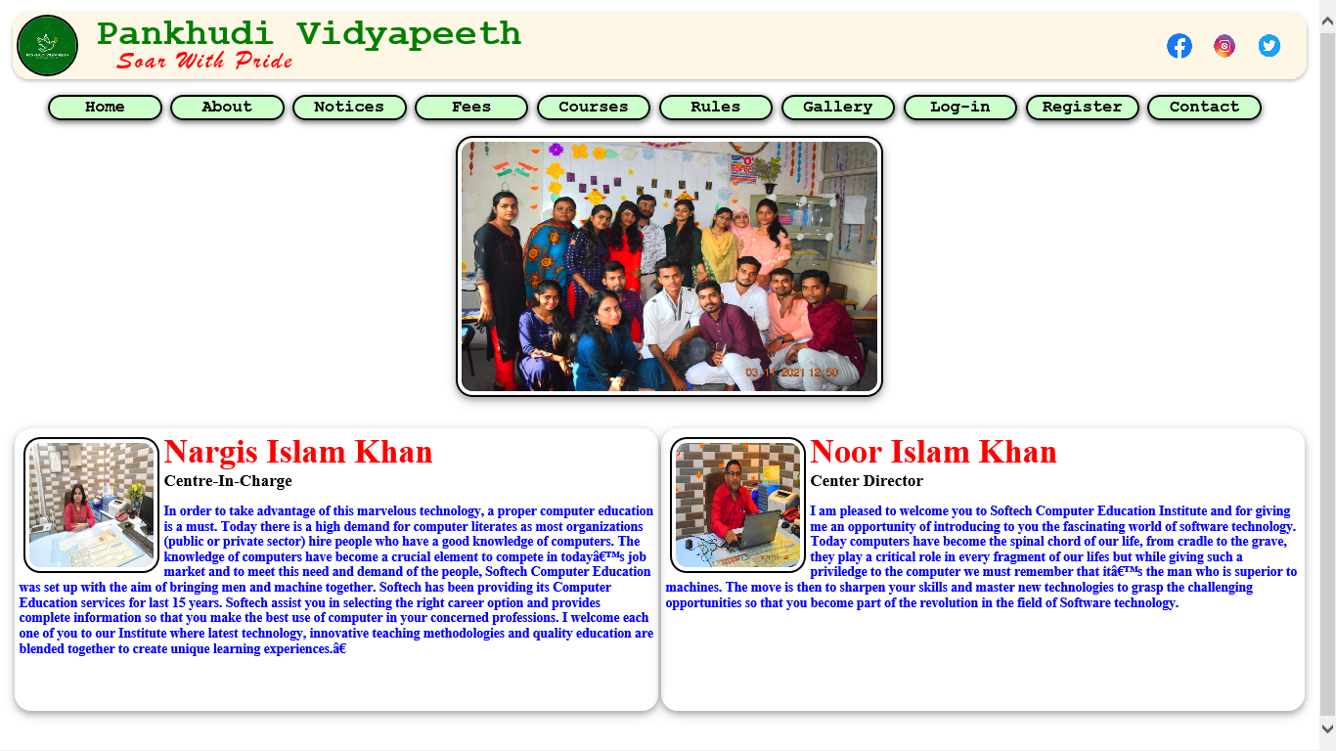

<!DOCTYPE html>

<html>

<head>

<title>Pankhudi Vidyapeeth</title>

<link rel="stylesheet" type="text/css" href="style.css">

<script type="text/javascript" src="script,js"></script>

<style>

.mySlides {display:none;border:2px solid black; width:400px; height:300px; box-shadow:0 4px 10px 0 rgba(0,0,0,0.2),0 4px 20px 0 rgba(0,0,0,0.19); border-radius:20px; padding:5px ;margin:5px}

.abc {width:100%}

.abc td{width:600px; height:400px}

.footer{width:100%;border-spacing:5px; border:2px solid black; border-radius:20px; box-shadow:0 4px 10px 0 rgba(0,0,0,0.2),0 4px 20px 0 rgba(0,0,0,0.19); background-color:lightgrey}

.footer img{border-radius:50px; }

</style>

</head>

<body>

<div class="header">

<div class="text1"> Pankhudi Vidyapeeth</div>

<div class="text2"> Soar With Pride</div>

<img src="images/logo2.png" class="logo">

<div class="social_media">

<a href="https://www.facebook.com"><img src="images/facebook.png"></a>

<a href="https://www,instagram.com"><img src="images/insta.png"></a>

<a href="https://www.twitter.com"><img src="images/twitter.png"></a>

</div>

</div>

<div class="menu">

<ol>

<a href="index.html"><li>Home</li></a>

<a href="about.html"><li>About</li></a>

<a href="notice.html"><li>Notices</li></a>

<a href="fees.html"><li>Fees</li></a>

<a href="courses.html"><li>Courses</li></a>

<a href="rules.html"><li>Rules</li></a>

<a href="gallery.html"><li>Gallery</li></a>

<a href="login.html"><li>Log-in</li></a>

<a href="signup.html"><li>Register</li></a>

<a href="contact.html"><li>Contact</li></a>

</ol>

</div>

<center>

<div class="w3-content w3-section" style="max-width:500px">

<img class="mySlides" src="imgf1.jpeg" style="width:500px">

<img class="mySlides" src="imgf2.jpeg" style="width:500px">

<img class="mySlides" src="imgf3.jpeg" style="width:500px">

<img class="mySlides" src="imgf4.jpeg" style="width:500px">

<img class="mySlides" src="imgf5.jpeg" style="width:500px">

<img class="mySlides" src="imgf6.jpeg" style="width:500px">

<img class="mySlides" src="imgf7.jpeg" style="width:500px">

</div></center>

<script>

var myIndex = 0;

carousel();

function carousel() {

var i;

var x = document.getElementsByClassName("mySlides");

for (i = 0; i < x.length; i++) {

x[i].style.display = "none";

}

myIndex++;

if (myIndex > x.length) {myIndex = 1}

x[myIndex-1].style.display = "block";

setTimeout(carousel, 1500); // Change image every 2 seconds

}

</script>

<table class="abc">

<tr> <td>

<div style="box-shadow:0 4px 10px 0 rgba(0,0,0,0.2),0 4px 20px 0 rgba(0,0,0,0.19); border-radius:20px; padding:5px; height:330px">

<img src="nargismam.jpeg" style="float:left; height:150px; width:150px;border:2px solid black;border-radius:20px; padding:5px; margin:5px "> <span style="font-size:40px; color:red">Nargis Islam Khan</span> <br> <span style="font-size:20px">Centre-In-Charge</span>

<p style="color:blue">

In order to take advantage of this marvelous technology, a proper computer education is a must. Today there is a high demand for computer literates as most organizations (public or private sector) hire people who have a good knowledge of computers. The knowledge of computers have become a crucial element to compete in today’s job market and to meet this need and demand of the people, Softech Computer Education was set up with the aim of bringing men and machine together. Softech has been providing its Computer Education services for last 15 years. Softech assist you in selecting the right career option and provides complete information so that you make the best use of computer in your concerned professions.

I welcome each one of you to our Institute where latest technology, innovative teaching methodologies and quality education are blended together to create unique learning experiences.”</p>

</div></td>

<td>

<div style="box-shadow:0 4px 10px 0 rgba(0,0,0,0.2),0 4px 20px 0 rgba(0,0,0,0.19); border-radius:20px; padding:5px; height:330px">

<img src="imgf5.jpeg" style="float:left; height:150px; width:150px;border:2px solid black;border-radius:20px; padding:5px; margin:5px "> <span style="font-size:40px; color:red">Noor Islam Khan</span> <br> <span style="font-size:20px"> Center Director</span>

<p style="color:blue"> I am pleased to welcome you to Softech Computer Education Institute and for giving me an opportunity of introducing to you the fascinating world of software technology.

Today computers have become the spinal chord of our life, from cradle to the grave, they play a critical role in every fragment of our lifes but while giving such a priviledge to the computer we must remember that it’s the man who is superior to machines. The move is then to sharpen your skills and master new technologies to grasp the challenging opportunities so that you become part of the revolution in the field of Software technology.

</p>

</div></td>

</tr></table>

</body>

</html>

**About.html**

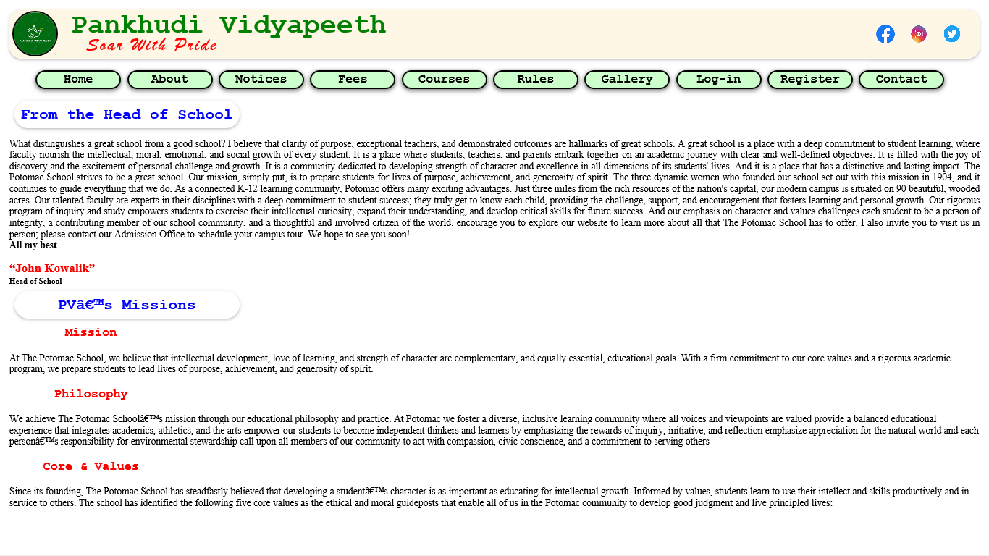<!DOCTYPE html>

<html>

<head>

<title>About Us</title>

<link rel="stylesheet" type="text/css" href="style.css">

<script type="text/javascript" src="script,js"></script>

</head>

<body>

<div class="header">

<div class="text1"> Pankhudi Vidyapeeth</div>

<div class="text2"> Soar With Pride</div>

<img src="images/logo2.png" class="logo">

<div class="social_media">

<a href="https://www.facebook.com"><img src="images/facebook.png"></a>

<a href="https://www,instagram.com"><img src="images/insta.png"></a>

<a href="https://www.twitter.com"><img src="images/twitter.png"></a>

</div>

</div>

<div class="menu">

<ol>

<a href="index.html"><li>Home</li></a>

<a href="about.html"><li>About</li></a>

<a href="notice.html"><li>Notices</li></a>

<a href="fees.html"><li>Fees</li></a>

<a href="courses.html"><li>Courses</li></a>

<a href="rules.html"><li>Rules</li></a>

<a href="gallery.html"><li>Gallery</li></a>

<a href="login.html"><li>Log-in</li></a>

<a href="signup.html"><li>Register</li></a>

<a href="contact.html"><li>Contact</li></a>

</ol>

</div>

<div class="page_subheader"> From the Head of School </div>

<p align="Justify">

What distinguishes a great school from a good school? I believe that clarity of purpose, exceptional teachers, and demonstrated outcomes are hallmarks of great schools. A great school is a place with a deep commitment to student learning, where faculty nourish the intellectual, moral, emotional, and social growth of every student. It is a place where students, teachers, and parents embark together on an academic journey with clear and well-defined objectives. It is filled with the joy of discovery and the excitement of personal challenge and growth. It is a community dedicated to developing strength of character and excellence in all dimensions of its students' lives. And it is a place that has a distinctive and lasting impact.

The Potomac School strives to be a great school. Our mission, simply put, is to prepare students for lives of purpose, achievement, and generosity of spirit. The three dynamic women who founded our school set out with this mission in 1904, and it continues to guide everything that we do.

As a connected K-12 learning community, Potomac offers many exciting advantages. Just three miles from the rich resources of the nation's capital, our modern campus is situated on 90 beautiful, wooded acres. Our talented faculty are experts in their disciplines with a deep commitment to student success; they truly get to know each child, providing the challenge, support, and encouragement that fosters learning and personal growth. Our rigorous program of inquiry and study empowers students to exercise their intellectual curiosity, expand their understanding, and develop critical skills for future success. And our emphasis on character and values challenges each student to be a person of integrity, a contributing member of our school community, and a thoughtful and involved citizen of the world.

encourage you to explore our website to learn more about all that The Potomac School has to offer. I also invite you to visit us in person; please contact our Admission Office to schedule your campus tour. We hope to see you soon!<BR><B>All my best</B></p>

<DIV>

<B><BIG STYLE="COLOR:RED; font-SIZE:20PX"> <Q>John Kowalik</Q></BIG><BR>

<SMALL>Head of School</SMALL></B></DIV>

<div class="page_subheader"> PV’s Missions </div>

<div class="page_sub_header"> Mission </div>

<p>At The Potomac School, we believe that intellectual development, love of learning, and strength of character are complementary, and equally essential, educational goals. With a firm commitment to our core values and a rigorous academic program, we prepare students to lead lives of purpose, achievement, and generosity of spirit.</p>

<div class="page_sub_header"> Philosophy</div>

<p>We achieve The Potomac School’s mission through our educational philosophy and practice. At Potomac we

foster a diverse, inclusive learning community where all voices and viewpoints are valued

provide a balanced educational experience that integrates academics, athletics, and the arts

empower our students to become independent thinkers and learners by emphasizing the rewards of inquiry, initiative, and reflection

emphasize appreciation for the natural world and each person’s responsibility for environmental stewardship

call upon all members of our community to act with compassion, civic conscience, and a commitment to serving others</p>

<div class="page_sub_header">Core & Values </div>

<p>Since its founding, The Potomac School has steadfastly believed that developing a student’s character is as important as educating for intellectual growth. Informed by values, students learn to use their intellect and skills productively and in service to others. The school has identified the following five core values as the ethical and moral guideposts that enable all of us in the Potomac community to develop good judgment and live principled lives:</p>

</body>

</html>

**Notices.html**

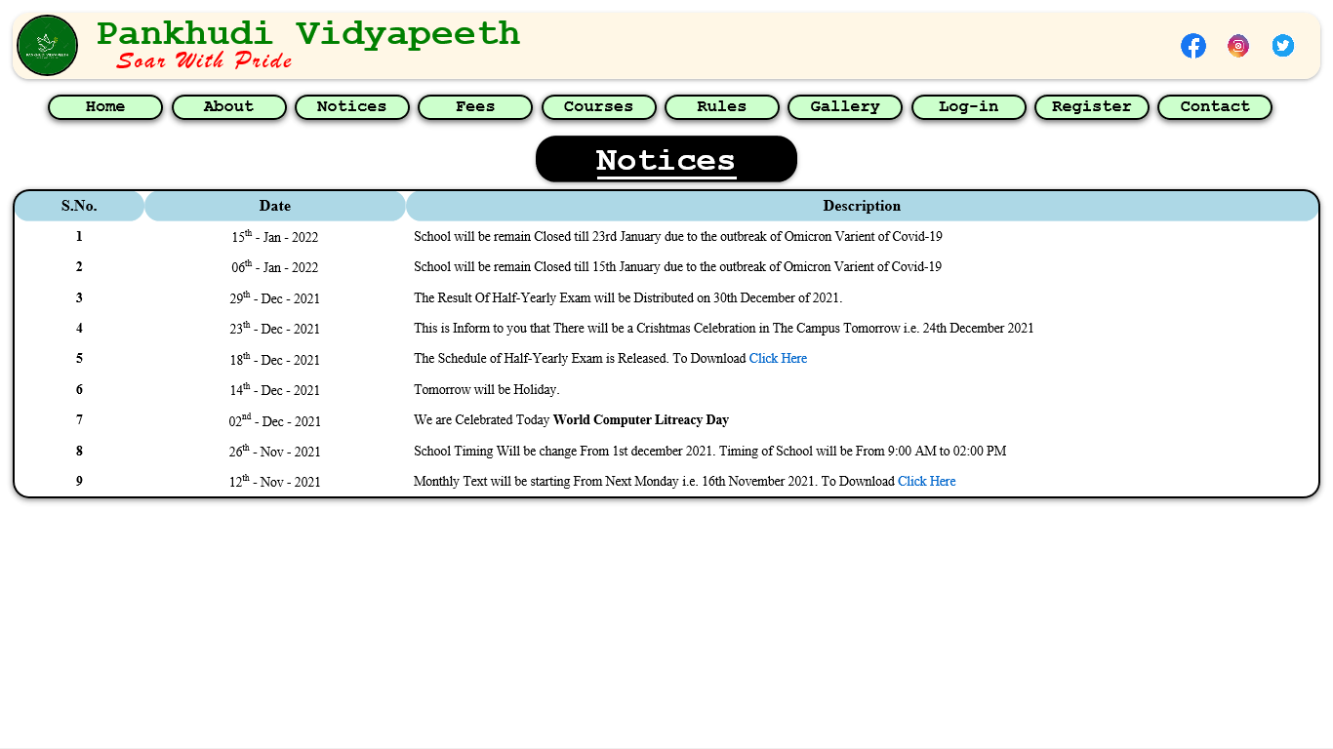<!DOCTYPE html>

<html>

<head>

<title>Notices</title>

<link rel="stylesheet" type="text/css" href="style.css">

<script type="text/javascript" src="script,js"></script>

</head>

<body>

<div class="header">

<div class="text1"> Pankhudi Vidyapeeth</div>

<div class="text2"> Soar With Pride</div>

<img src="images/logo2.png" class="logo">

<div class="social_media">

<a href="https://www.facebook.com"><img src="images/facebook.png"></a>

<a href="https://www,instagram.com"><img src="images/insta.png"></a>

<a href="https://www.twitter.com"><img src="images/twitter.png"></a>

</div>

</div>

<div class="menu">

<ol>

<a href="index.html"><li>Home</li></a>

<a href="about.html"><li>About</li></a>

<a href="notice.html"><li>Notices</li></a>

<a href="fees.html"><li>Fees</li></a>

<a href="courses.html"><li>Courses</li></a>

<a href="rules.html"><li>Rules</li></a>

<a href="gallery.html"><li>Gallery</li></a>

<a href="login.html"><li>Log-in</li></a>

<a href="signup.html"><li>Register</li></a>

<a href="contact.html"><li>Contact</li></a>

</ol></div>

<center><div class="page_header"> Notices </div></center>

<table class="notice">

<tr style="font-size: 19px; background-color: lightblue"> <th class="sn">S.No.</th> <th class="dt" style="font-weight: bold"> Date </th> <th class="Dsp" style="font-weight: bold"> Description </th> </tr>

<tr> <td class="sn">1</td> <td class="dt"> 15<sup>th</sup> - Jan - 2022 </td> <td class="Dsp"> School will be remain Closed till 23rd January due to the outbreak of Omicron Varient of Covid-19</td> </tr>

<tr> <td class="sn">2</td> <td class="dt"> 06<sup>th</sup> - Jan - 2022 </td> <td class="Dsp"> School will be remain Closed till 15th January due to the outbreak of Omicron Varient of Covid-19 </td> </tr>

<tr> <td class="sn">3</td> <td class="dt"> 29<sup>th</sup> - Dec - 2021 </td> <td class="Dsp"> The Result Of Half-Yearly Exam will be Distributed on 30th December of 2021. </td> </tr>

<tr> <td class="sn">4</td> <td class="dt"> 23<sup>th</sup> - Dec - 2021 </td> <td class="Dsp"> This is Inform to you that There will be a Crishtmas Celebration in The Campus Tomorrow i.e. 24th December 2021</td> </tr>

<tr> <td class="sn">5</td> <td class="dt"> 18<sup>th</sup> - Dec - 2021 </td> <td class="Dsp"> The Schedule of Half-Yearly Exam is Released. To Download <a href="exam.pdf"> Click Here</a> </td> </tr>

<tr> <td class="sn">6</td> <td class="dt"> 14<sup>th</sup> - Dec - 2021 </td> <td class="Dsp"> Tomorrow will be Holiday. </td> </tr>

<tr> <td class="sn">7</td> <td class="dt"> 02<sup>nd</sup> - Dec - 2021 </td> <td class="Dsp"> We are Celebrated Today <b>World Computer Litreacy Day</b> </td> </tr>

<tr> <td class="sn">8</td> <td class="dt"> 26<sup>th</sup> - Nov - 2021 </td> <td class="Dsp"> School Timing Will be change From 1st december 2021. Timing of School will be From 9:00 AM to 02:00 PM </td> </tr>

<tr> <td class="sn">9</td> <td class="dt"> 12<sup>th</sup> - Nov - 2021 </td> <td class="Dsp"> Monthly Text will be starting From Next Monday i.e. 16th November 2021. To Download <a href="exam.pdf"> Click Here</a> </td> </tr>

</table>

</body>

</html>

**Fee.html**

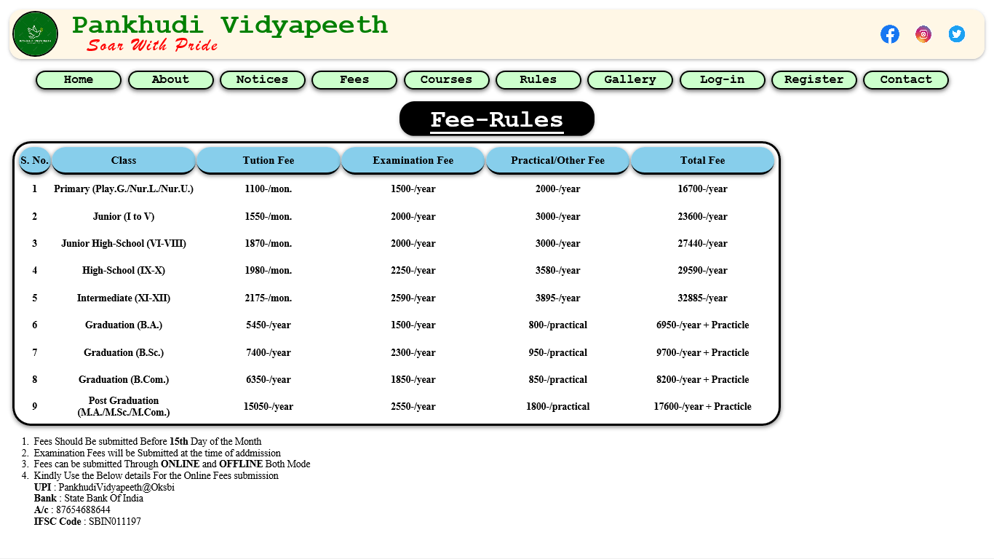<!DOCTYPE html>

<html>

<head>

<title>Fee-Structure</title>

<link rel="stylesheet" type="text/css" href="style.css">

<script type="text/javascript" src="script,js"></script>

</head>

<body>

<div class="header">

<div class="text1"> Pankhudi Vidyapeeth</div>

<div class="text2"> Soar With Pride</div>

<img src="images/logo2.png" class="logo">

<div class="social_media">

<a href="https://www.facebook.com"><img src="images/facebook.png"></a>

<a href="https://www,instagram.com"><img src="images/insta.png"></a>

<a href="https://www.twitter.com"><img src="images/twitter.png"></a>

</div>

</div>

<div class="menu">

<ol>

<a href="index.html"><li>Home</li></a>

<a href="about.html"><li>About</li></a>

<a href="notice.html"><li>Notices</li></a>

<a href="fees.html"><li>Fees</li></a>

<a href="courses.html"><li>Courses</li></a>

<a href="rules.html"><li>Rules</li></a>

<a href="gallery.html"><li>Gallery</li></a>

<a href="login.html"><li>Log-in</li></a>

<a href="signup.html"><li>Register</li></a>

<a href="contact.html"><li>Contact</li></a>

</ol>

</div>

<center><div class="page_header"> Fee-Rules </div></center>

<table class="fee">

<tr class="fr"> <th class="idn"> S. No.</th> <th> Class </th> <th> Tution Fee </th> <th> Examination Fee</th> <th>Practical/Other Fee</th> <th>Total Fee</th> </tr>

<tr> <td class="idn"> 1 </td> <td> Primary (Play.G./Nur.L./Nur.U.) </td> <td> 1100-/mon. </td> <td> 1500-/year </td> <td> 2000-/year</td> <td>16700-/year</td> </tr>

<tr> <td class="idn"> 2 </td> <td> Junior (I to V) </td> <td> 1550-/mon. </td> <td> 2000-/year </td> <td> 3000-/year</td> <td>23600-/year</td> </tr>

<tr> <td class="idn"> 3 </td> <td> Junior High-School (VI-VIII) </td> <td> 1870-/mon. </td> <td> 2000-/year </td> <td> 3000-/year</td> <td>27440-/year</td> </tr>

<tr> <td class="idn"> 4 </td> <td> High-School (IX-X) </td> <td> 1980-/mon. </td> <td> 2250-/year </td> <td> 3580-/year</td> <td>29590-/year</td> </tr>

<tr> <td class="idn"> 5 </td> <td> Intermediate (XI-XII) </td> <td> 2175-/mon. </td> <td> 2590-/year </td> <td> 3895-/year</td> <td>32885-/year</td> </tr>

<tr> <td class="idn"> 6 </td> <td> Graduation (B.A.) </td> <td> 5450-/year </td> <td> 1500-/year </td> <td> 800-/practical </td> <td> 6950-/year + Practicle</td> </tr>

<tr> <td class="idn"> 7 </td> <td> Graduation (B.Sc.) </td> <td> 7400-/year </td> <td> 2300-/year </td> <td> 950-/practical </td> <td> 9700-/year + Practicle</td> </tr>

<tr> <td class="idn"> 8 </td> <td> Graduation (B.Com.) </td> <td> 6350-/year </td> <td> 1850-/year </td> <td> 850-/practical </td> <td> 8200-/year + Practicle</td> </tr>

<tr> <td class="idn"> 9 </td> <td> Post Graduation (M.A./M.Sc./M.Com.) </td> <td> 15050-/year </td> <td> 2550-/year </td> <td> 1800-/practical </td> <td> 17600-/year + Practicle</td> </tr>

</table>

<ol>

<li> Fees Should Be submitted Before <b>15th</b> Day of the Month </li>

<li> Examination Fees will be Submitted at the time of addmission</li>

<li>Fees can be submitted Through <b>ONLINE</b> and <b>OFFLINE</b> Both Mode</li>

<li> Kindly Use the Below details For the Online Fees submission <br>

<b>UPI </b>: PankhudiVidyapeeth@Oksbi <br>

<b>Bank </b>: State Bank Of India <br>

<b>A/c </b>: 87654688644 <br>

<b>IFSC Code </b>: SBIN011197

</li></ol>

</ol>

</body>

</html>

Courses.html

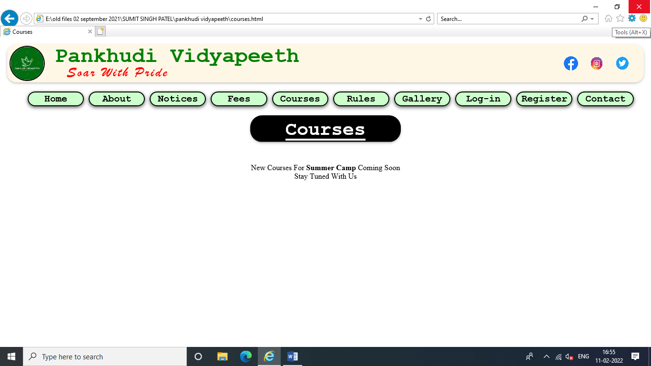<!DOCTYPE html>

<html>

<head>

<title>Courses</title>

<link rel="stylesheet" type="text/css" href="style.css">

<script type="text/javascript" src="script,js"></script>

</head>

<body>

<div class="header">

<div class="text1"> Pankhudi Vidyapeeth</div>

<div class="text2"> Soar With Pride</div>

<img src="images/logo2.png" class="logo">

<div class="social_media">

<a href="https://www.facebook.com"><img src="images/facebook.png"></a>

<a href="https://www,instagram.com"><img src="images/insta.png"></a>

<a href="https://www.twitter.com"><img src="images/twitter.png"></a>

</div>

</div>

<div class="menu">

<ol>

<a href="index.html"><li>Home</li></a>

<a href="about.html"><li>About</li></a>

<a href="notice.html"><li>Notices</li></a>

<a href="fees.html"><li>Fees</li></a>

<a href="courses.html"><li>Courses</li></a>

<a href="rules.html"><li>Rules</li></a>

<a href="gallery.html"><li>Gallery</li></a>

<a href="login.html"><li>Log-in</li></a>

<a href="signup.html"><li>Register</li></a>

<a href="contact.html"><li>Contact</li></a>

</ol>

</div>

<center><div class="page_header"> Courses </div></center>

<center><br><br>New Courses For <b>Summer Camp</b> Coming Soon <br> Stay Tuned With Us</center>

</div>

</body>

</html>

**Rules.html**

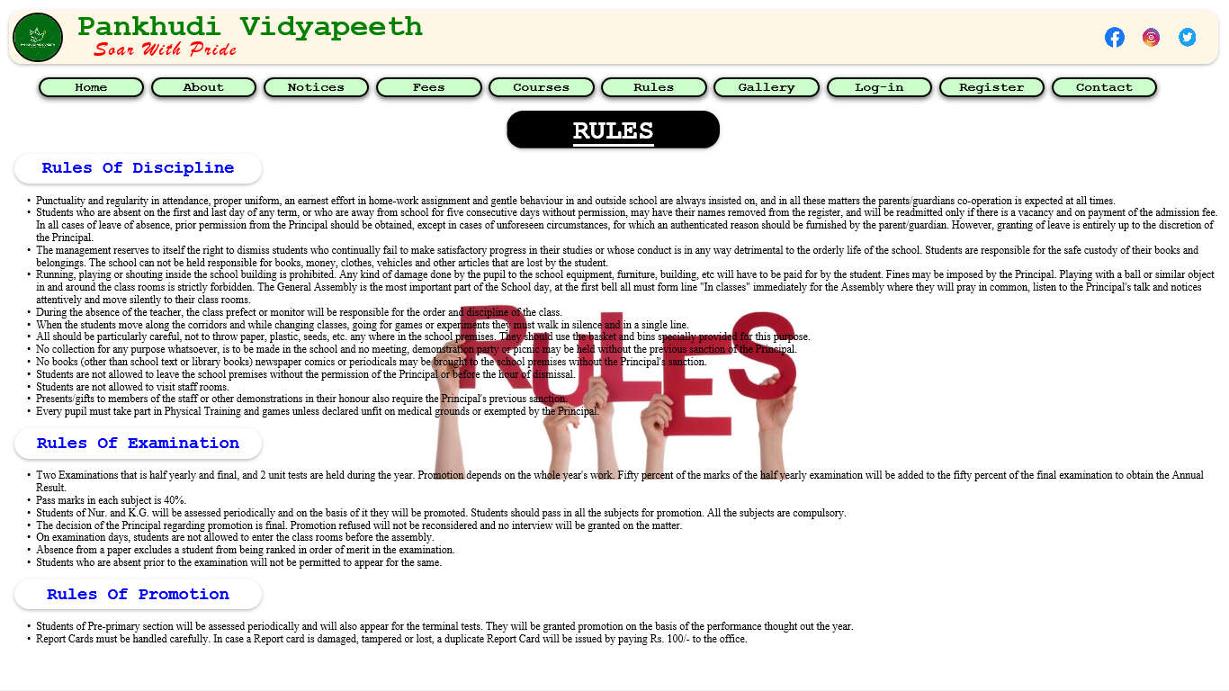<!DOCTYPE html>

<html>

<head>

<title>Rules</title>

<link rel="stylesheet" type="text/css" href="style.css">

<script type="text/javascript" src="script,js"></script>

</head>

<body style="background-image: url(images/rule.jpg); background-repeat: no-repeat;background-position: center;background-attachment: fixed;">

<div class="header">

<div class="text1"> Pankhudi Vidyapeeth</div>

<div class="text2"> Soar With Pride</div>

<img src="images/logo2.png" class="logo">

<div class="social_media">

<a href="https://www.facebook.com"><img src="images/facebook.png"></a>

<a href="https://www,instagram.com"><img src="images/insta.png"></a>

<a href="https://www.twitter.com"><img src="images/twitter.png"></a>

</div>

</div>

<div class="menu">

<ol>

<a href="index.html"><li>Home</li></a>

<a href="about.html"><li>About</li></a>

<a href="notice.html"><li>Notices</li></a>

<a href="fees.html"><li>Fees</li></a>

<a href="courses.html"><li>Courses</li></a>

<a href="rules.html"><li>Rules</li></a>

<a href="gallery.html"><li>Gallery</li></a>

<a href="login.html"><li>Log-in</li></a>

<a href="signup.html"><li>Register</li></a>

<a href="contact.html"><li>Contact</li></a>

</ol>

</div>

<center><div class="page_header"> RULES </div></center>

<div class="page_subheader"> Rules Of Discipline </div>

<ul>

<li>Punctuality and regularity in attendance, proper uniform, an earnest effort in home-work assignment and gentle behaviour in and outside school are always insisted on, and in all these matters the parents/guardians co-operation is expected at all times.</li>

<li>Students who are absent on the first and last day of any term, or who are away from school for five consecutive days without permission, may have their names removed from the register, and will be readmitted only if there is a vacancy and on payment of the admission fee. In all cases of leave of absence, prior permission from the Principal should be obtained, except in cases of unforeseen circumstances, for which an authenticated reason should be furnished by the parent/guardian. However, granting of leave is entirely up to the discretion of the Principal.</li>

<li>The management reserves to itself the right to dismiss students who continually fail to make satisfactory progress in their studies or whose conduct is in any way detrimental to the orderly life of the school.

Students are responsible for the safe custody of their books and belongings. The school can not be held responsible for books, money, clothes, vehicles and other articles that are lost by the student.</li>

<li>Running, playing or shouting inside the school building is prohibited. Any kind of damage done by the pupil to the school equipment, furniture, building, etc will have to be paid for by the student. Fines may be imposed by the Principal. Playing with a ball or similar object in and around the class rooms is strictly forbidden.

The General Assembly is the most important part of the School day, at the first bell all must form line "In classes" immediately for the Assembly where they will pray in common, listen to the Principal's talk and notices attentively and move silently to their class rooms.</li>

<li>During the absence of the teacher, the class prefect or monitor will be responsible for the order and discipline of the class.</li>

<li>When the students move along the corridors and while changing classes, going for games or experiments they must walk in silence and in a single line.</li>

<li>All should be particularly careful, not to throw paper, plastic, seeds, etc. any where in the school premises. They should use the basket and bins specially provided for this purpose.</li>

<li>No collection for any purpose whatsoever, is to be made in the school and no meeting, demonstration party or picnic may be held without the previous sanction of the Principal.</li>

<li>No books (other than school text or library books) newspaper comics or periodicals may be brought to the school premises without the Principal's sanction.</li>

<li>Students are not allowed to leave the school premises without the permission of the Principal or before the hour of dismissal.</li>

<li>Students are not allowed to visit staff rooms.</li>

<li>Presents/gifts to members of the staff or other demonstrations in their honour also require the Principal's previous sanction.</li>

<li>Every pupil must take part in Physical Training and games unless declared unfit on medical grounds or exempted by the Principal.</li>

</ul>

<div class="page_subheader"> Rules Of Examination </div>

<ul>

<li>Two Examinations that is half yearly and final, and 2 unit tests are held during the year. Promotion depends on the whole year's work. Fifty percent of the marks of the half yearly examination will be added to the fifty percent of the final examination to obtain the Annual Result.</li>

<li>Pass marks in each subject is 40%.</li>

<li>Students of Nur. and K.G. will be assessed periodically and on the basis of it they will be promoted.

Students should pass in all the subjects for promotion. All the subjects are compulsory.</li>

<li>The decision of the Principal regarding promotion is final. Promotion refused will not be reconsidered and no interview will be granted on the matter.</li>

<li>On examination days, students are not allowed to enter the class rooms before the assembly.</li>

<li>Absence from a paper excludes a student from being ranked in order of merit in the examination.</li>

<li>Students who are absent prior to the examination will not be permitted to appear for the same.</li>

</ul>

<div class="page_subheader"> Rules Of Promotion </div>

<UL>

<LI>

Students of Pre-primary section will be assessed periodically and will also appear for the terminal tests. They will be granted promotion on the basis of the performance thought out the year.</LI>

<LI>Report Cards must be handled carefully. In case a Report card is damaged, tampered or lost, a duplicate Report Card will be issued by paying Rs. 100/- to the office.

</LI>

</UL>

</body>

</html>

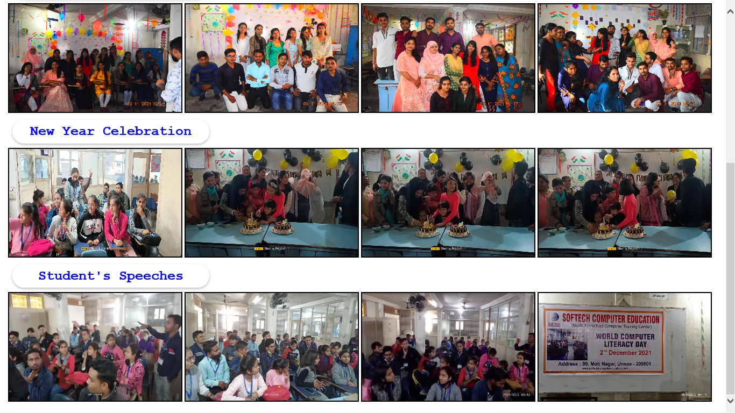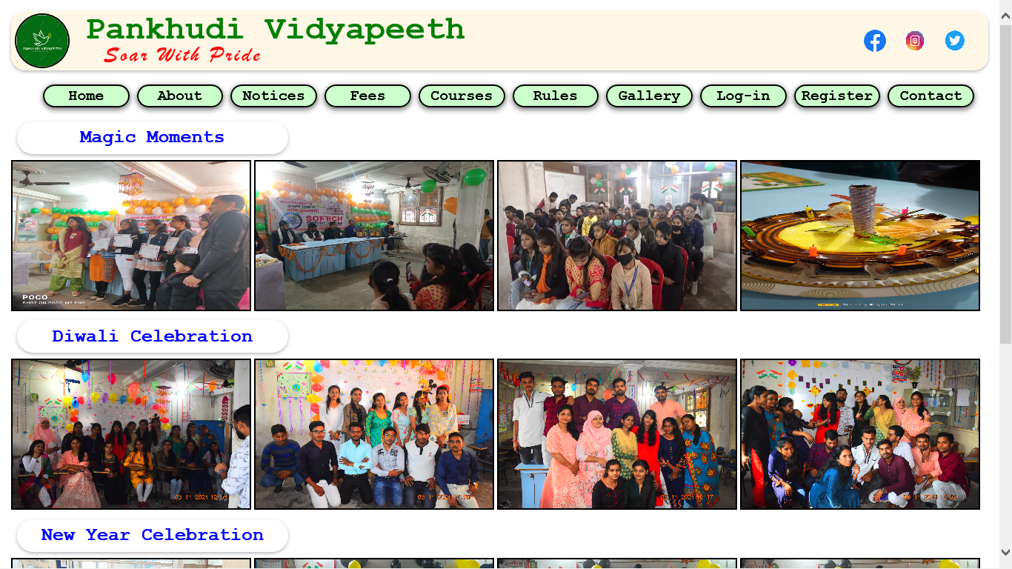**Gallery.html**

<!DOCTYPE html>

<html>

<head>

<title>Gallery</title>

<link rel="stylesheet" type="text/css" href="style.css">

<script type="text/javascript" src="script,js"></script>

</head>

<body>

<div class="header">

<div class="text1"> Pankhudi Vidyapeeth</div>

<div class="text2"> Soar With Pride</div>

<img src="images/logo2.png" class="logo">

<div class="social_media">

<a href="https://www.facebook.com"><img src="images/facebook.png"></a>

<a href="https://www,instagram.com"><img src="images/insta.png"></a>

<a href="https://www.twitter.com"><img src="images/twitter.png"></a>

</div>

</div>

<div class="menu">

<ol>

<a href="index.html"><li>Home</li></a>

<a href="about.html"><li>About</li></a>

<a href="notice.html"><li>Notices</li></a>

<a href="fees.html"><li>Fees</li></a>

<a href="courses.html"><li>Courses</li></a>

<a href="rules.html"><li>Rules</li></a>

<a href="gallery.html"><li>Gallery</li></a>

<a href="login.html"><li>Log-in</li></a>

<a href="signup.html"><li>Register</li></a>

<a href="contact.html"><li>Contact</li></a>

</ol>

</div>

<div class="page_subheader"> Magic Moments</div>

<div class="gllry">

<img src="images/gly5.jpg" >

<img src="images/gly6.jpg" >

<img src="images/gly7.jpg" >

<img src="images/gly8.jpg" >

</div>

<div class="page_subheader"> Diwali Celebration</div>

<div class="gllry">

<img src="images/gly1.jpg" >

<img src="images/gly2.jpg" >

<img src="images/gly3.jpg" >

<img src="images/gly4.jpg" >

</div>

<div class="page_subheader"> New Year Celebration</div>

<div class="gllry">

<img src="images/gly9.jpg" >

<img src="images/gly10.jpg" >

<img src="images/gly11.jpg" >

<img src="images/gly12.jpg" >

</div>

<div class="page_subheader"> Student's Speeches</div>

<div class="gllry">

<img src="images/gly13.jpg" >

<img src="images/gly14.jpg" >

<img src="images/gly15.jpg" >

<img src="images/gly16.jpg" >

</div>

</body>

</html>

**LogIn.html**

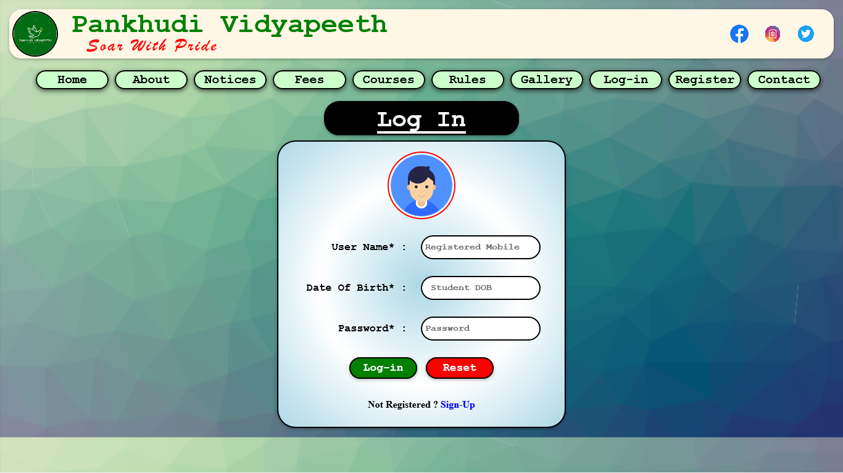<!DOCTYPE html>

<html>

<head>

<title>Log-In</title>

<link rel="stylesheet" type="text/css" href="style.css">

<script type="text/javascript" src="script,js"></script>

</head>

<body class="login">

<div class="header">

<div class="text1"> Pankhudi Vidyapeeth</div>

<div class="text2"> Soar With Pride</div>

<img src="images/logo2.png" class="logo">

<div class="social_media">

<a href="https://www.facebook.com"><img src="images/facebook.png"></a>

<a href="https://www,instagram.com"><img src="images/insta.png"></a>

<a href="https://www.twitter.com"><img src="images/twitter.png"></a>

</div>

</div>

<div class="menu">

<ol>

<a href="index.html"><li>Home</li></a>

<a href="about.html"><li>About</li></a>

<a href="notice.html"><li>Notices</li></a>

<a href="fees.html"><li>Fees</li></a>

<a href="courses.html"><li>Courses</li></a>

<a href="rules.html"><li>Rules</li></a>

<a href="gallery.html"><li>Gallery</li></a>

<a href="login.html"><li>Log-in</li></a>

<a href="signup.html"><li>Register</li></a>

<a href="contact.html"><li>Contact</li></a>

</ol>

</div>

<center><div class="page_header"> Log In </div></center>

<form method="post">

<table class="login_form" align="center">

<tr><td colspan="2" align="center" class="form_img"><img src="images/user.png "></td></tr>

<tr> <td class="form_heading"> User Name* : </td> <td> <input type="text" name="uname" placeholder="Registered Mobile"> </td> </tr>

<tr> <td class="form_heading"> Date Of Birth* : </td> <td> <input type="Date" name="dob" placeholder=" Student DOB"> </td> </tr>

<tr> <td class="form_heading"> Password* : </td> <td> <input type="Password" name="password" placeholder="Password "> </td> </tr>

<tr> <td colspan="2" align="center"> <input type="submit" name="submit" value="Log-in"> <input type="Reset" name="reset" value="Reset"> </td> </tr>

<tr> <td colspan="2" align="center"> Not Registered ? <a href="signup.html" style="color: blue; font-weight: bold">Sign-Up</a> </td> </tr>

</table>

</form>

</body>

</html>

**Signup.html**

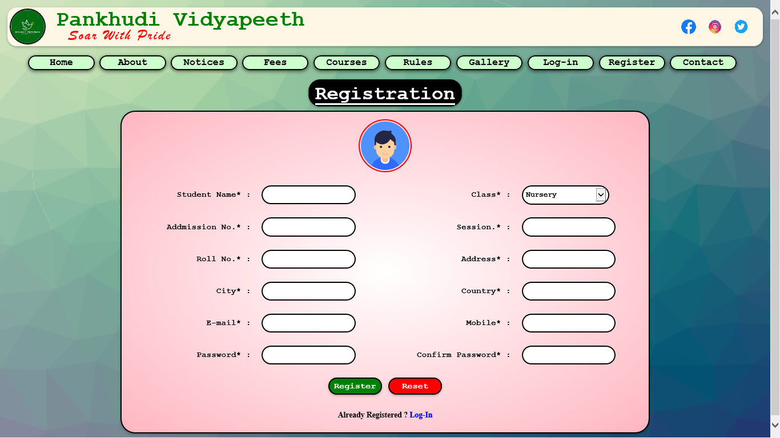<!DOCTYPE html>

<html>

<head>

<title>registration</title>

<link rel="stylesheet" type="text/css" href="style.css">

<script type="text/javascript" src="script,js"></script>

</head>

<body class="signup">

<div class="header">

<div class="text1"> Pankhudi Vidyapeeth</div>

<div class="text2"> Soar With Pride</div>

<img src="images/logo2.png" class="logo">

<div class="social_media">

<a href="https://www.facebook.com"><img src="images/facebook.png"></a>

<a href="https://www,instagram.com"><img src="images/insta.png"></a>

<a href="https://www.twitter.com"><img src="images/twitter.png"></a>

</div>

</div>

<div class="menu">

<ol>

<a href="index.html"><li>Home</li></a>

<a href="about.html"><li>About</li></a>

<a href="notice.html"><li>Notices</li></a>

<a href="fees.html"><li>Fees</li></a>

<a href="courses.html"><li>Courses</li></a>

<a href="rules.html"><li>Rules</li></a>

<a href="gallery.html"><li>Gallery</li></a>

<a href="login.html"><li>Log-in</li></a>

<a href="signup.html"><li>Register</li></a>

<a href="contact.html"><li>Contact</li></a>

</ol>

</div>

<center><div class="page_header"> Registration </div></center>

<form method="post">

<table class="sign_form" align="center">

<tr><td colspan="4" align="center" class="form_img"><img src="images/user.png "></td></tr>

<tr> <td class="form_heading"> Student Name* :</td> <td> <input type="text" name="uname"> </td> <td class="form_heading"> Class* :</td> <td> <select>

<option value="Nursery"> Nursery </option>

<option value="junior"> Junior </option>

<option value="J-HS"> junior High-School </option>

<option value="High-school"> High School </option>

<option value="Inter"> Intermediate </option>

<option value="Graduation"> Graduation </option>

<option value="PG"> Post-Graduation </option>

</select> </td></tr>

<tr> <td class="form_heading"> Addmission No.* :</td> <td> <input type="text" name="add" > </td> <td class="form_heading"> Session.* :</td> <td> <input type="year" name="Session" > </td></tr>

<tr> <td class="form_heading"> Roll No.* :</td> <td> <input type="text" name="rn" pattern="[0-9]{3}" > </td> <td class="form_heading"> Address* :</td> <td> <input type="text" name="addr"> </td></tr>

<tr> <td class="form_heading"> City* :</td> <td> <input type="text" name="city"> </td> <td class="form_heading"> Country* :</td> <td> <input type="text" name="cntry"> </td></tr>

<tr> <td class="form_heading"> E-mail* :</td> <td> <input type="email" name="email" > </td> <td class="form_heading"> Mobile* :</td> <td> <input type="text" name="mobile" pattern="[0-9]{10}" > </td></tr>

<tr> <td class="form_heading"> Password* : </td> <td> <input type="Password" name="password" > </td> <td class="form_heading"> Confirm Password* : </td> <td> <input type="Password" name="cnfpassword"> </td> </tr>

<tr> <td colspan="4" align="center"> <input type="submit" name="submit" value="Register"> <input type="Reset" name="reset" value="Reset"> </td> </tr>

<tr> <td colspan="4" align="center"> Already Registered ? <a href="login.html" style="color: blue; font-weight: bold">Log-In</a> </td> </tr>

</table>

</form>

</body>

</html>

**Contact.html**

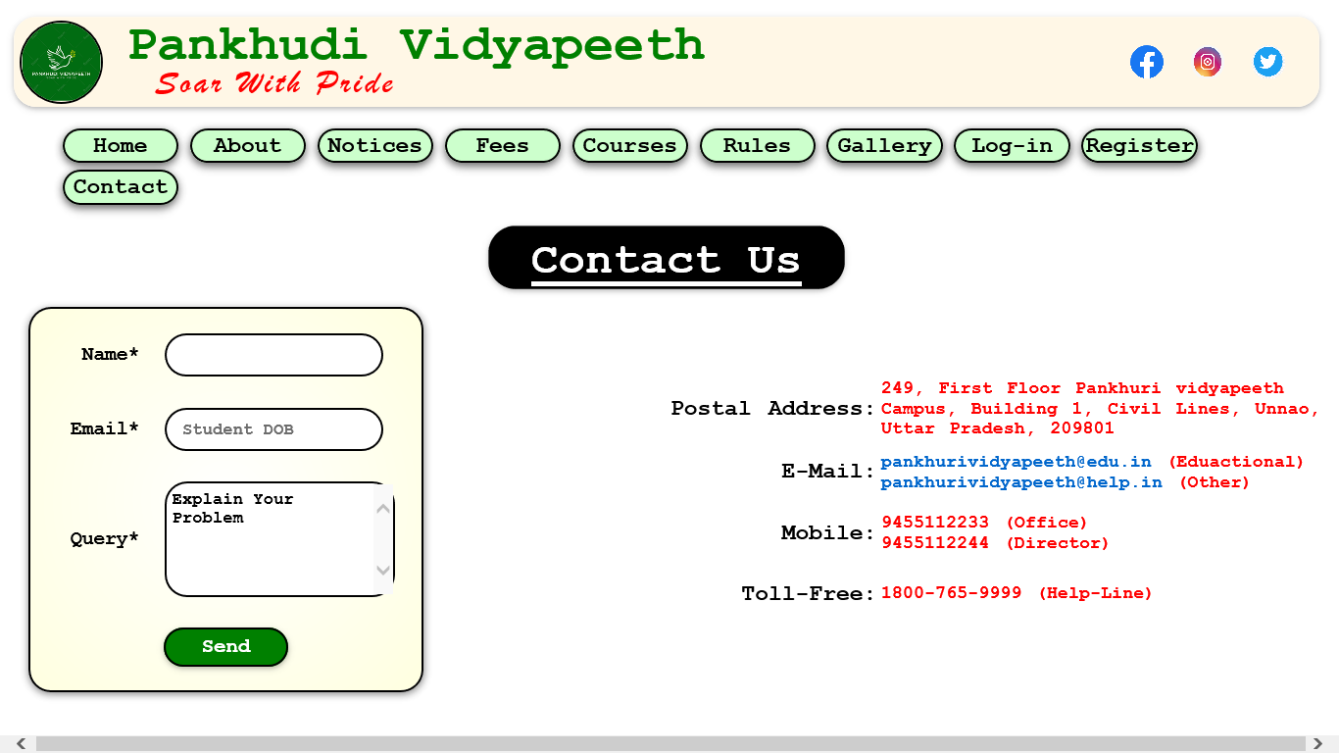<!DOCTYPE html>

<html>

<head>

<title>Contact-Us</title>

<link rel="stylesheet" type="text/css" href="style.css">

<script type="text/javascript" src="script,js"></script>

</head>

<body>

<div class="header">

<div class="text1"> Pankhudi Vidyapeeth</div>

<div class="text2"> Soar With Pride</div>

<img src="images/logo2.png" class="logo">

<div class="social_media">

<a href="https://www.facebook.com"><img src="images/facebook.png"></a>

<a href="https://www,instagram.com"><img src="images/insta.png"></a>

<a href="https://www.twitter.com"><img src="images/twitter.png"></a>

</div>

</div>

<div class="menu">

<ol>

<a href="index.html"><li>Home</li></a>

<a href="about.html"><li>About</li></a>

<a href="notice.html"><li>Notices</li></a>

<a href="fees.html"><li>Fees</li></a>

<a href="courses.html"><li>Courses</li></a>

<a href="rules.html"><li>Rules</li></a>

<a href="gallery.html"><li>Gallery</li></a>

<a href="login.html"><li>Log-in</li></a>

<a href="signup.html"><li>Register</li></a>

<a href="contact.html"><li>Contact</li></a>

</ol>

</div>

<center><div class="page_header"> Contact Us </div></center>

<table class="contact" align="center">

<tr>

<td>

<form method="post">

<table class="contact_form" align="center">

<tr> <td class="form_heading"> Name* </td> <td> <input type="text" name="uname" > </td> </tr>

<tr> <td class="form_heading"> Email* </td> <td> <input type="Date" name="dob" placeholder=" Student DOB"> </td> </tr>

<tr> <td class="form_heading"> Query* </td> <td> <textarea style="width: 191px; height: 88px;">Explain Your Problem</textarea> </td> </tr>

<tr> <td colspan="2" align="center"> <input type="submit" name="submit" value="Send"> </td> </tr>

</table>

</form>

</td>

<td>

<table class="info">

<tr> <td class="form_heading">Postal Address: </td> <td> 249, First Floor Pankhuri vidyapeeth Campus, Building 1, Civil Lines, Unnao, Uttar Pradesh, 209801</td></tr>

<tr> <td class="form_heading">E-Mail: </td> <td> <a href="mailto:PankhuriVidyapeeth@edu.in">pankhurividyapeeth@edu.in</a> (Eduactional) <br> <a href="mailto:PankhuriVidyapeeth@help.in">pankhurividyapeeth@help.in</a> (Other) </td></tr>

<tr> <td class="form_heading">Mobile: </td> <td> 9455112233 (Office) <br> 9455112244 (Director) </td></tr>

<tr> <td class="form_heading">Toll-Free: </td> <td> 1800-765-9999 (Help-Line) </td></tr>

</table>

</td>

</tr>

</table>

</body>

</html>